R Programming Assignment:

Problem Statement:

In bike-sharing systems, the entire process from membership to rental and return

has been automated. Using these systems, users can easily rent a bike from one

location and return it to another. Hence, a bike rental company wants to

understand and predict the number of bikes rented daily based on the

environment and seasons.

Task 1: Exploratory Data Analysis

#Load the dataset and the relevant libraries

Code:



Output:

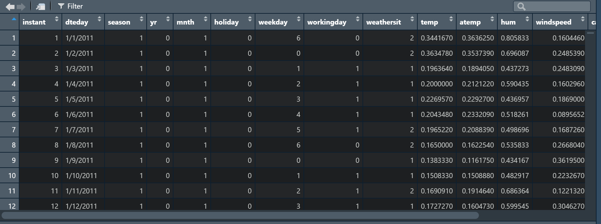

#Perform data type conversion of the attributes

#Carry out the missing value Analysis

Code:



Output:

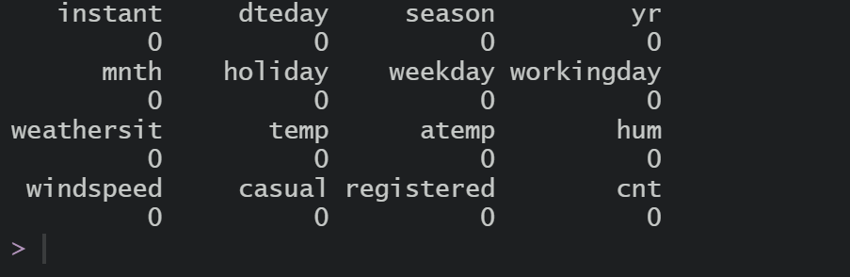

Task 2: Attributes distribution and trends:

#Plot monthly distribution of the total number of bikes rented

#Plot yearly distribution of the total number of bikes rented

Code:



Output:

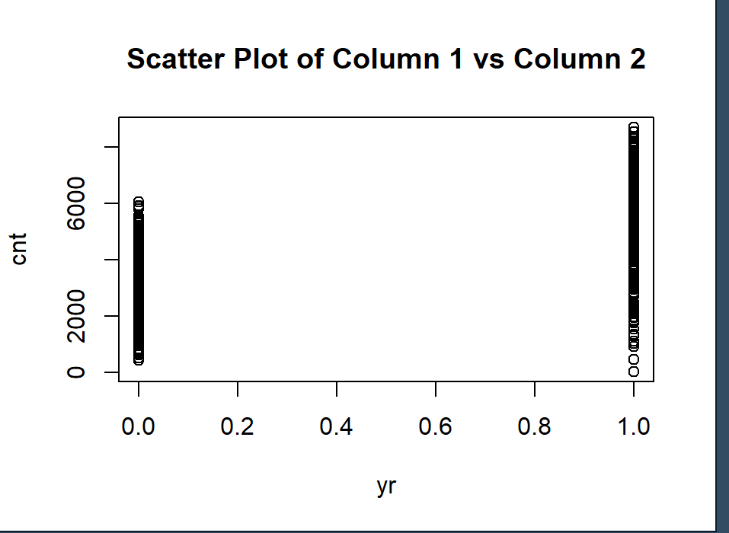

# Plot boxplot for outliers analysis

Code:

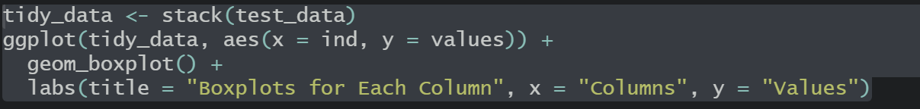

Output:



Task:3 Split the dataset into train and test dataset

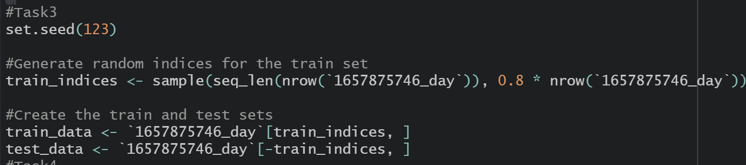

Task 4:

Create a model using the random forest algorithm:

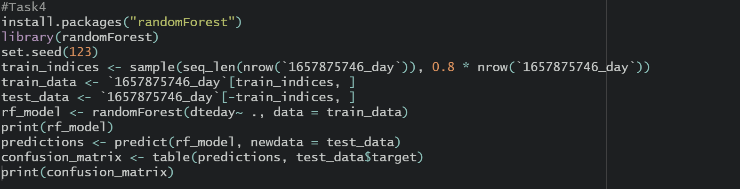

Task:5 Predict the performance of the model on the test dataset

